1. **16 bit addition**

**Code:**

lhld 2001

xchg

lhld 2005

dad d

shld 2010

hlt

**OUT PUT:**

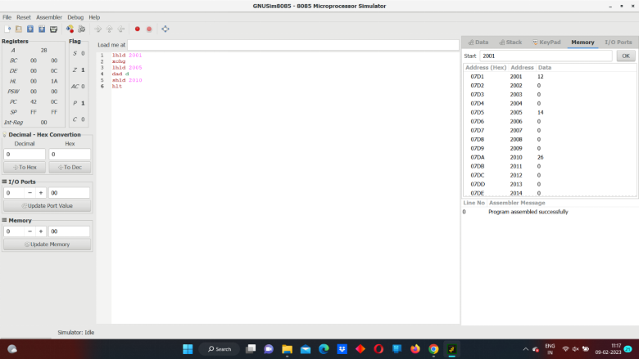ss